CYBR3030 – Cryptography Case Study Report
Prepared for: Bruce Wayne, Edmonton Comics
Prepared by: Cybersecurity Consultant

Table of Contents
1. Summary
2. Network Diagram
3. Gap Analysis & Risks
4. Cryptographic Methods for Data Protection
5. Algorithm Comparison
6. Recommendations
7. References

Summary
Edmonton Comics has expanded its operations to collaborate with two external partners, requiring secure data sharing and strong cryptographic protections. This report examines current security gaps—including plaintext password storage, use of a self-signed certificate, and insufficient encryption controls—and proposes industry-standard cryptographic solutions. Recommendations include implementing CA-signed TLS certificates, encrypting all data at rest using AES-256, enforcing secure API communication with TLS 1.3, and adopting modern password hashing schemes. These changes will significantly reduce the risk of unauthorized access, data theft, and network compromise.

Network Diagram
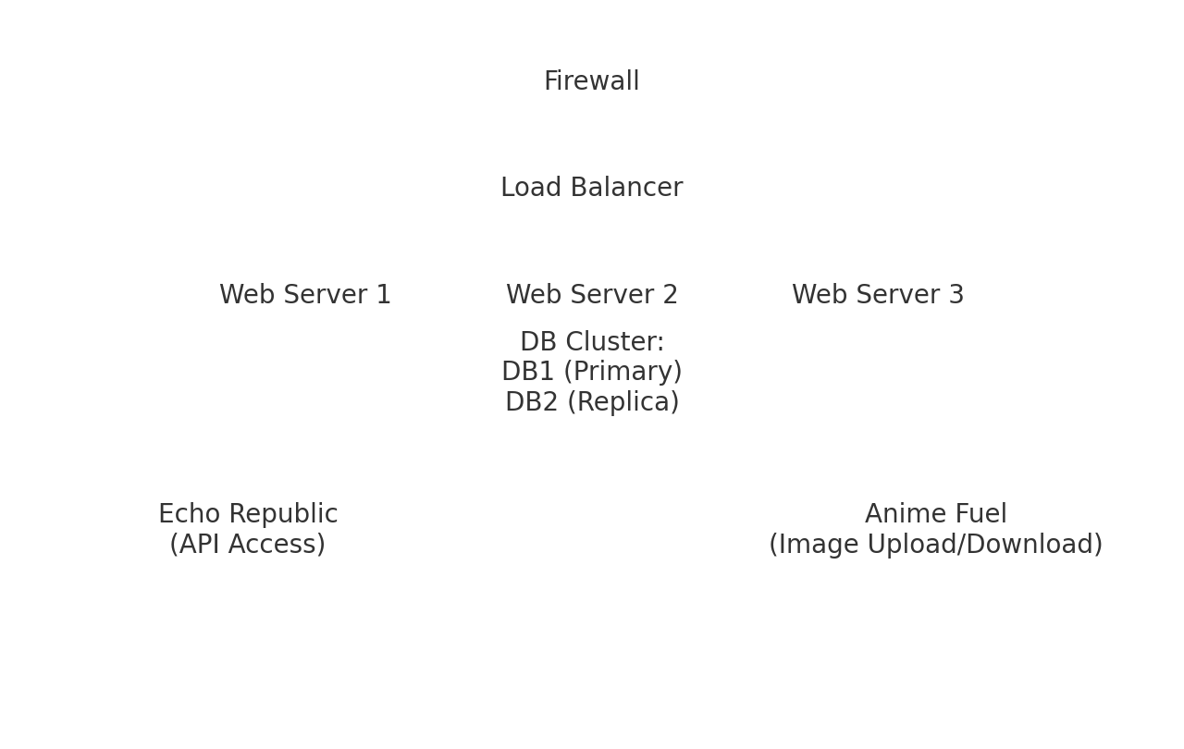

Gap Analysis & Risks
The following gaps and risks have been identified in the current Edmonton Comics environment:
1. **Plaintext Credential Storage** – Storing usernames and passwords in plaintext exposes the organization to immediate compromise if attackers access the server file system.
2. **Self-Signed Certificate Usage** – A self-signed certificate does not provide authenticity validation, making the network vulnerable to man-in-the-middle (MITM) attacks.
3. **Unsecured Partner Access** – Echo Republic and Anime Fuel rely on web-based access without enforced cryptographic standards, increasing risk of eavesdropping.
4. **Lack of Encryption for Data at Rest** – Databases storing sensitive content and intellectual property are not encrypted, making them vulnerable if compromised.
5. **Weak Authentication Controls** – No MFA or cryptographic token-based authentication mechanisms are in place.
6. **Potential API Exploitation** – Echo Republic’s API integration could be abused without secure signing, rate limiting, or encrypted endpoints.
7. **Insufficient Network Segmentation** – Web servers and databases appear to be closely linked without additional isolation, increasing lateral movement risk.
8. **Undefined Logging and Key Management Policies** – Cryptographic operations require secure key rotation, storage, and monitoring—all currently missing.

Cryptographic Methods for Data Protection
**1. Data in Transit:**
TLS 1.3 provides encrypted communication, forward secrecy, and modern cipher suites. It ensures that partner organizations accessing APIs and image files do so securely.
**2. Data at Rest:**
AES-256 encryption should be used for databases, file storage, and backups. It provides strong confidentiality and is efficient for large datasets.
**3. Password Protection:**
Passwords must be hashed—not stored—using PBKDF2, bcrypt, or Argon2. Argon2 is preferred for its memory-hard properties.
**4. Key Management:**
Keys should be stored in a Hardware Security Module (HSM) or a secure key vault such as AWS KMS or Azure Key Vault.
**5. Digital Certificates:**
Using CA-signed certificates ensures trusted identity validation during communications.

Algorithm Comparison
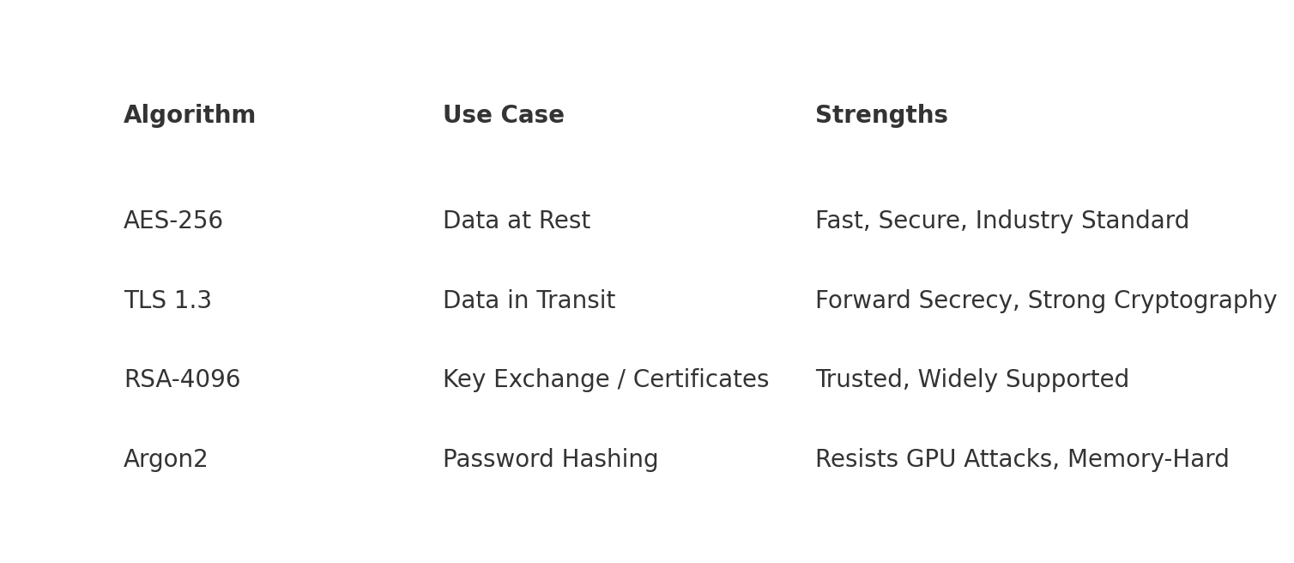
This comparison highlights the differences between cryptographic algorithms used for confidentiality, authentication, and secure key exchange. AES-256 is optimal for encrypting large volumes of stored data, while TLS 1.3 with RSA-4096 or ECDHE key exchange protects data in transit. Argon2 provides state-of-the-art password hashing resistant to GPU and ASIC attacks.

Recommendations
Based on the analysis, the following actions are strongly recommended:
• **Replace self-signed certificates** with certificates issued by a trusted Certificate Authority.
• **Implement TLS 1.3** across all web and API communication channels.
• **Enforce password hashing** using Argon2 or PBKDF2.
• **Encrypt all data at rest** using AES-256.
• **Introduce multi-factor authentication (MFA)** for all administrative and partner accounts.
• **Deploy secure API tokens** and validation mechanisms for Echo Republic integration.
• **Separate network zones** to reduce lateral movement.
• **Establish a cryptographic key management lifecycle**, including rotation and audit logging.
**Conclusion:** A self-signed certificate is not sufficient for current or future projects due to expansion, partner involvement, and increased cyber risk. CA-signed certificates are essential for ensuring identity validation and preventing MITM attacks.

References
- NIST Special Publication 800-57: Recommendation for Key Management
- NIST Special Publication 800-63: Digital Identity Guidelines
- OWASP Cryptographic Storage Guidelines
- CIS Controls v8

